* **Title Page: cs 1011-051 – Lab 10 <*ParkingLots*>**
* <Denise Malisa>
* <13/11/2020>
* <Page Break>
* **I. Objectives**

The purpose of this lab was for an ArrayList to be implemented in the previous lab, lab 9. Specific number of parking lots will be open at a time. And depending on how well there are meeting demanding more parking lots will be open if not. Otherwise the program basically serves the same purpose as the previous one.

* **II. Requirements**

An ArrayList is created and then the District class is modified to make use of the array.

**III. Design:**

|  |
| --- |
| ParkingLot |
| +CLOSED_THRESHOLD: double {readOnly} = 80.0 -name: String {readOnly}  -capacity: int  -closedStatus: Boolean = false  -availableParking: int  -occupiedParking: int  -totalMintuesClosed: int  -timeClosed: int  -timeOpen: int  -totalTime: int  -previousTime: int |
| +ParkingLot(name: String, capacity: int) +ParkingLot(capacity: int) +getMinutesClosed(): int +getName (): String +getNumberOfSpotsRemaining(): int +getPercentFull(): double +isClosed(): boolean +markVehicleEntry(timestamp: int): void +markVehicleExit(timestamp: int): void +toString(): String |

|  |
| --- |
| District |
| -lots: ArrayList<ParkingLot>  -numLots: int |
| +District()  +addLot(name: String, capacity: int): int  +getLot(index: int): ParkingLot  +getMinutesClosed(): int +getName (): String +getNumberOfSpotsRemaining(): int +getPercentFull(): double +isClosed(): boolean +markVehicleEntry(timestamp: int): void +markVehicleExit(timestamp: int): void +toString(): String |

* **III. Test Plan/Test Strategy**
* The ParkingLotsDriver class was used to check for errors and wrong values for both Classes.
* **IV. Results**

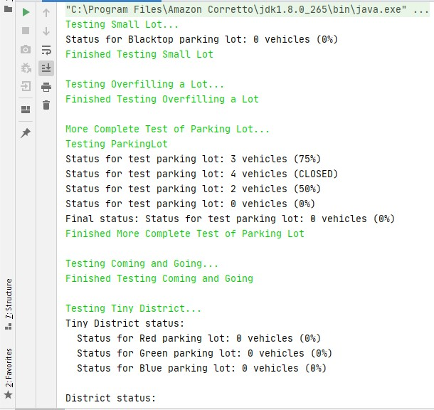

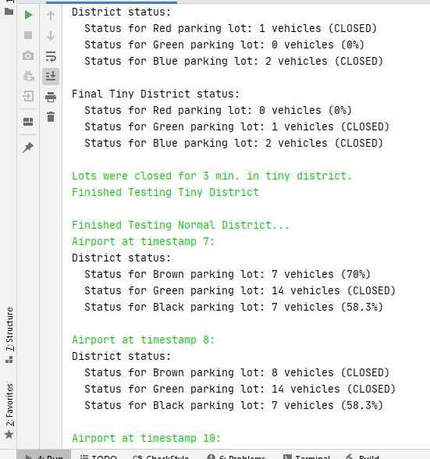

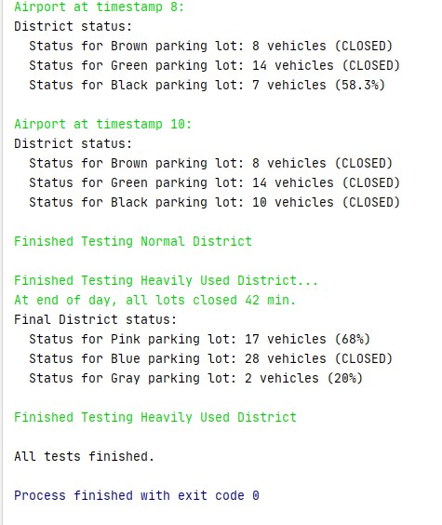

* **V. Discussion**

I learned how to correctly implement an ArrayList and how to modify the addLot method.